|  |
| --- |
| FUNDAMENTALS OF DATA ANALYTICS WITH TABLEAU  PROJECT TITLE    ILLUMINATING INSISGHTS FROM  UBER EXPEDITIONARY ANALYSIS  NAAN MUDHALVAN PROJECT ID:    NM2003TMID20455    TEAM MEMBERS:   1. R.MANIKANDAN[TEAM LEADER] 2. S.MANIKANDAN 3. G.SATHESH 4. K.THAYANITHI   DEPARTMENT OF MATHEMATICS    SREE SEVUGAN ANNAMALAI COLLEGE  DEVAKOTTAI |

**UNLOCKING INSIGHT INTO THE**

**UNER EXPEDITIONARY ANALYSIS**

**INTRODUCTION:**

|  |
| --- |
| **Description of project:** |

Uber is a multinational transportation network company that operates

a ride-hailing platform. It was founded in 2009 by Garrett Camp and Travis Kalanick and is based in San Francisco, California. Uber provides a convenient way for individuals to request rides from drivers who use their own personal vehicles. Uber Driver Analysis refers to the Analyzing the number of trips taken by Uber drivers can provide insights into their overall activity and the demand for rides in specific areas. Daily, Weekly, or Monthly Analysis: Uber's data can be analyzed on a daily, weekly, monthly basis to understand the trends and patterns of trip volumes. This analysis can help identify peak hours or days of high demand and optimize driver availability during those times. Trips can be analyzed based on geographic regions or specific cities to identify areas with higher demand. This analysis can help Uber drivers decide where to focus their driving efforts for maximum efficiency and profitability. The Major of our project is to use data Analyzing techniques to find unknown patterns in the Uber Drives dataset. The research is carried out on Uber drives data collected from the year 2016.

**Uses:**

It s use to analyses the details of transportation network.

|  |
| --- |
| **PROBLEM DEFINITION & DESIGH THINGING:** |

**EMPATHY MAP:**

First we make a empathy map for a group idea .To create a empathy map

from mural web site and logic with email account and search the templates

that you wanted to create.

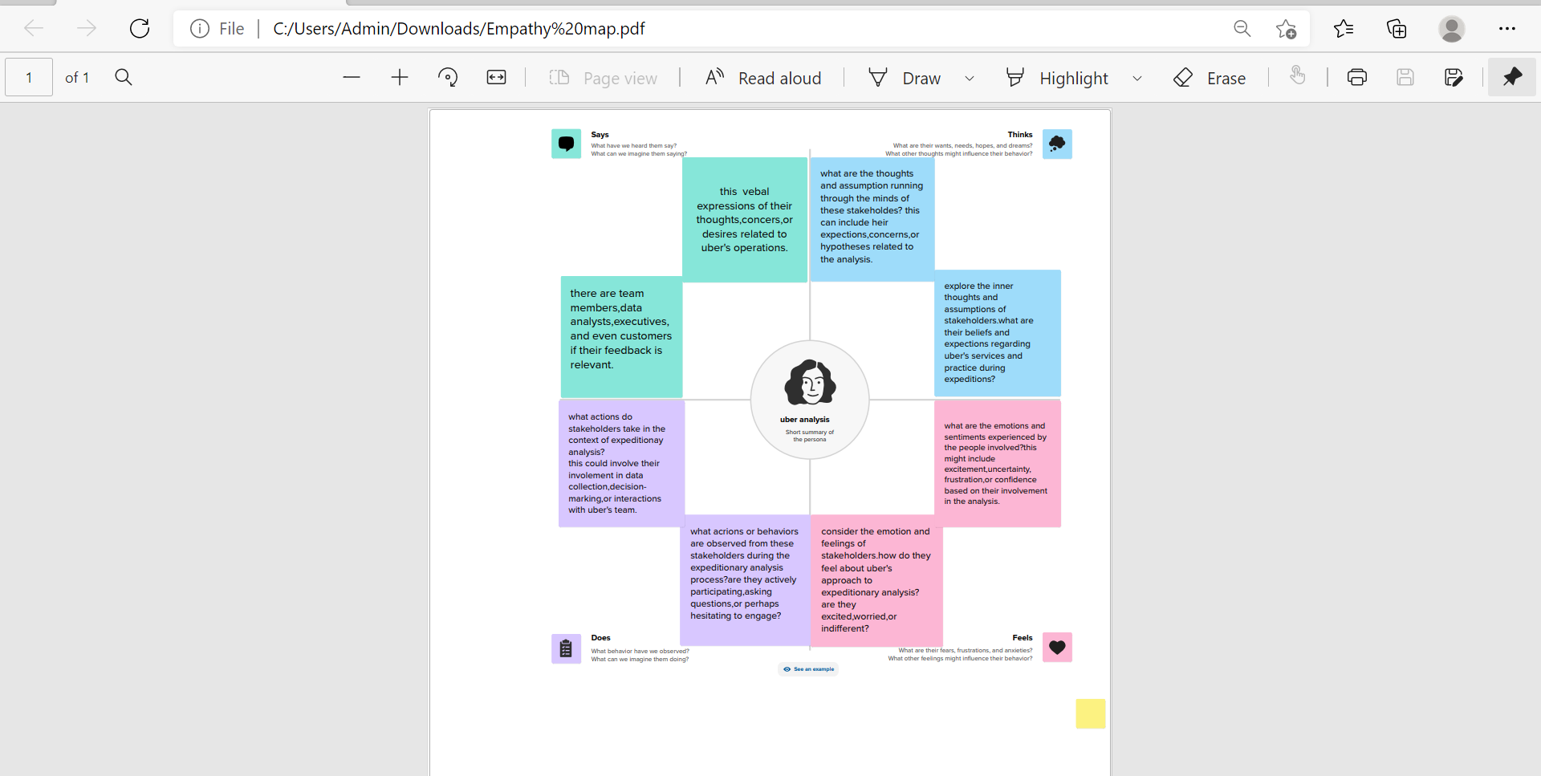

BRAINSTROMING MAP:

Then make a brainstorm map with mural website. I brainstorm we discussed the define problem and understand the problem. First we have defined what are the problems and types in the question box. Then it is a group idea and write in the box as person1, person2 and person 3. Now three person give different idea for the same problem. Take best three idea and type in last box.

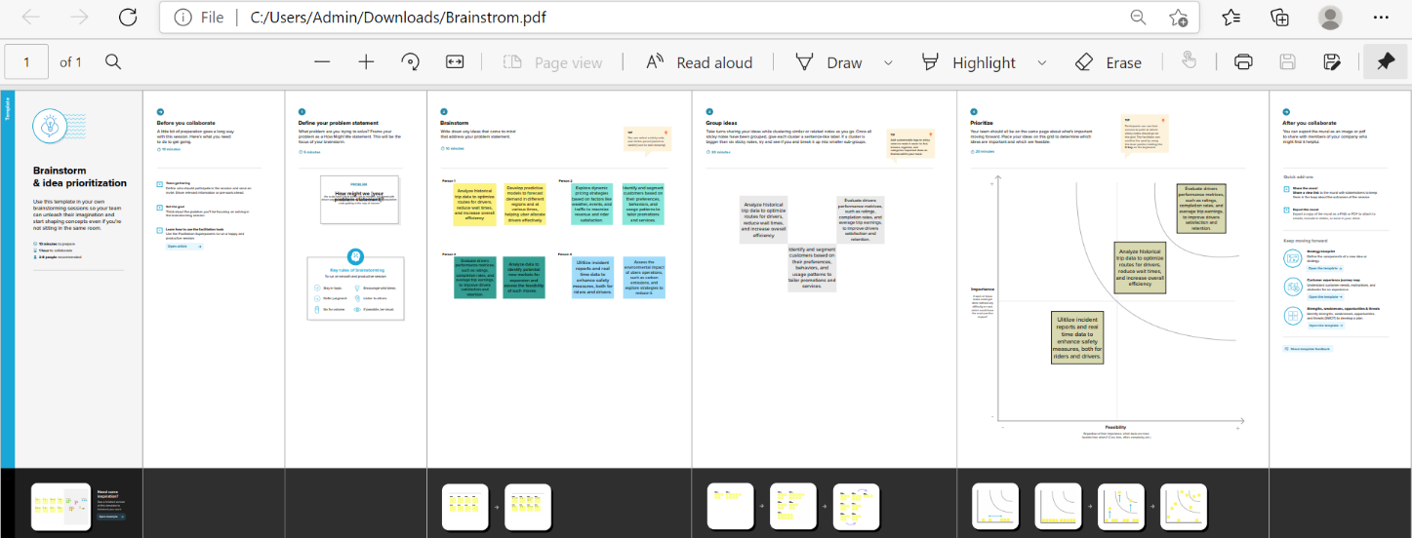

|  |
| --- |
| **PROCEDURE FOR TABLEAU PROJECT:** |

Before opening the tableau desktop We had download the dataset for you project.

After download the dataset We open the tableau desktop

After opening the selected link connect to data, select the “more” option and select the dataset.

It opens in the data source, now We arranged the data and select the “extract” option for the better performance for you analysis. We have arranged our project in the order uber data is first, after we saved the data.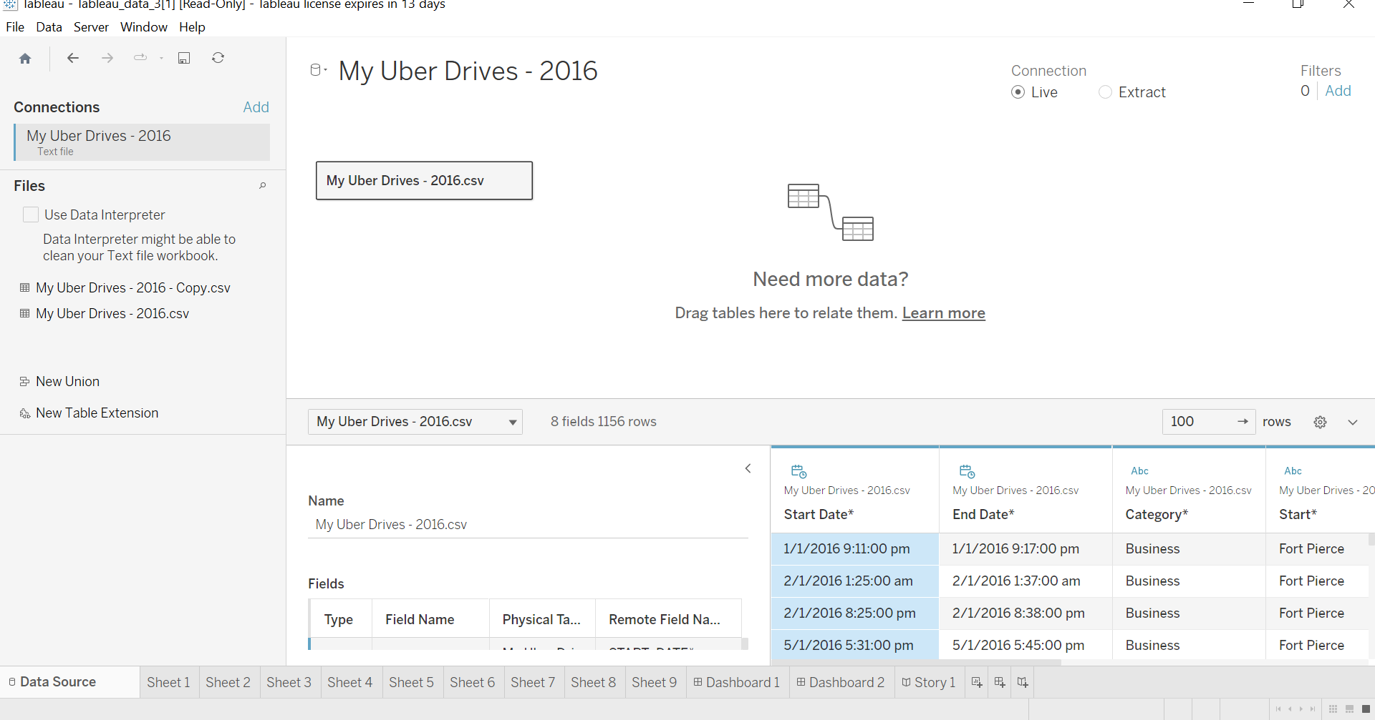

Wehave made 9 analysis sheet. The first sheet we made is a map contains the datails of number of ubers. And the second one the map show the high amplitude og uber , Then the details of total number of ubers . The next the bar graph is show the latitude and longitude.

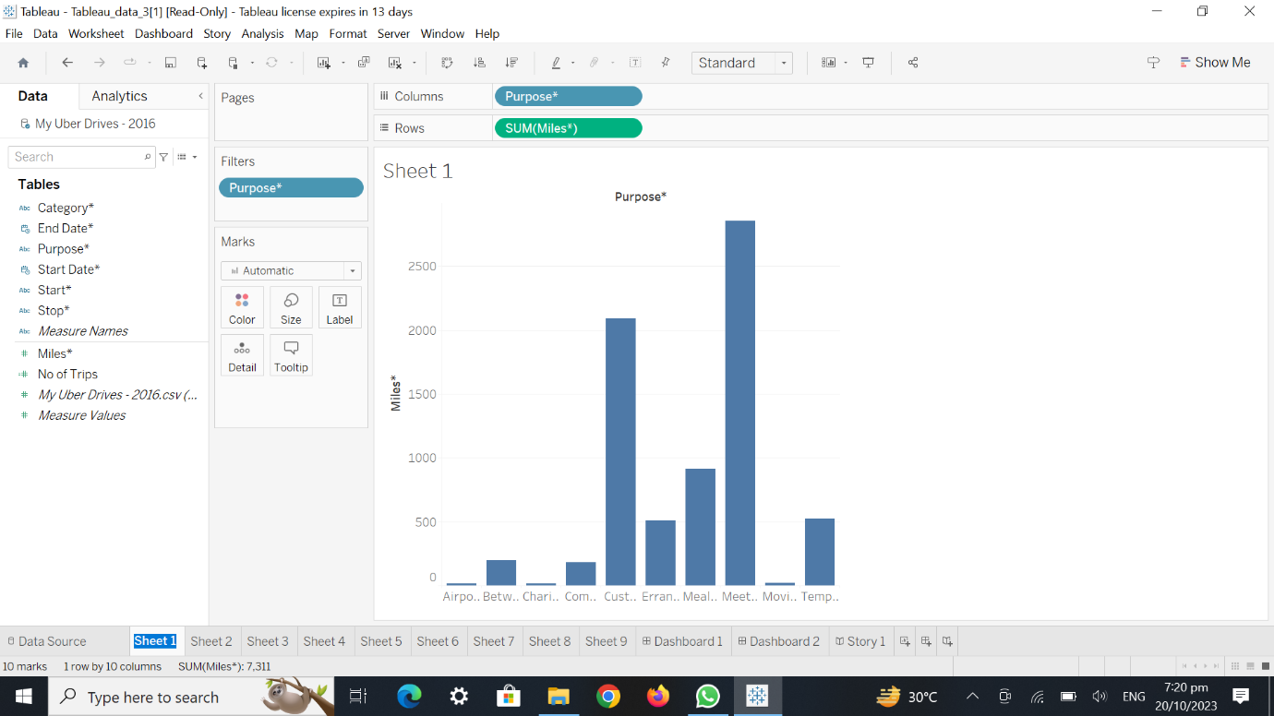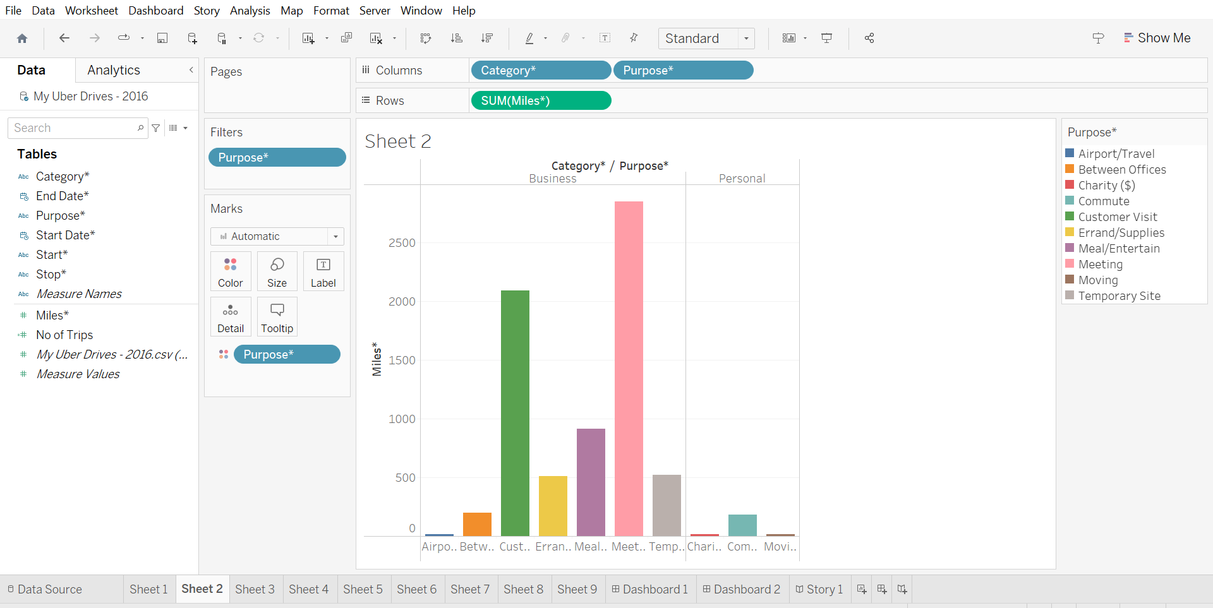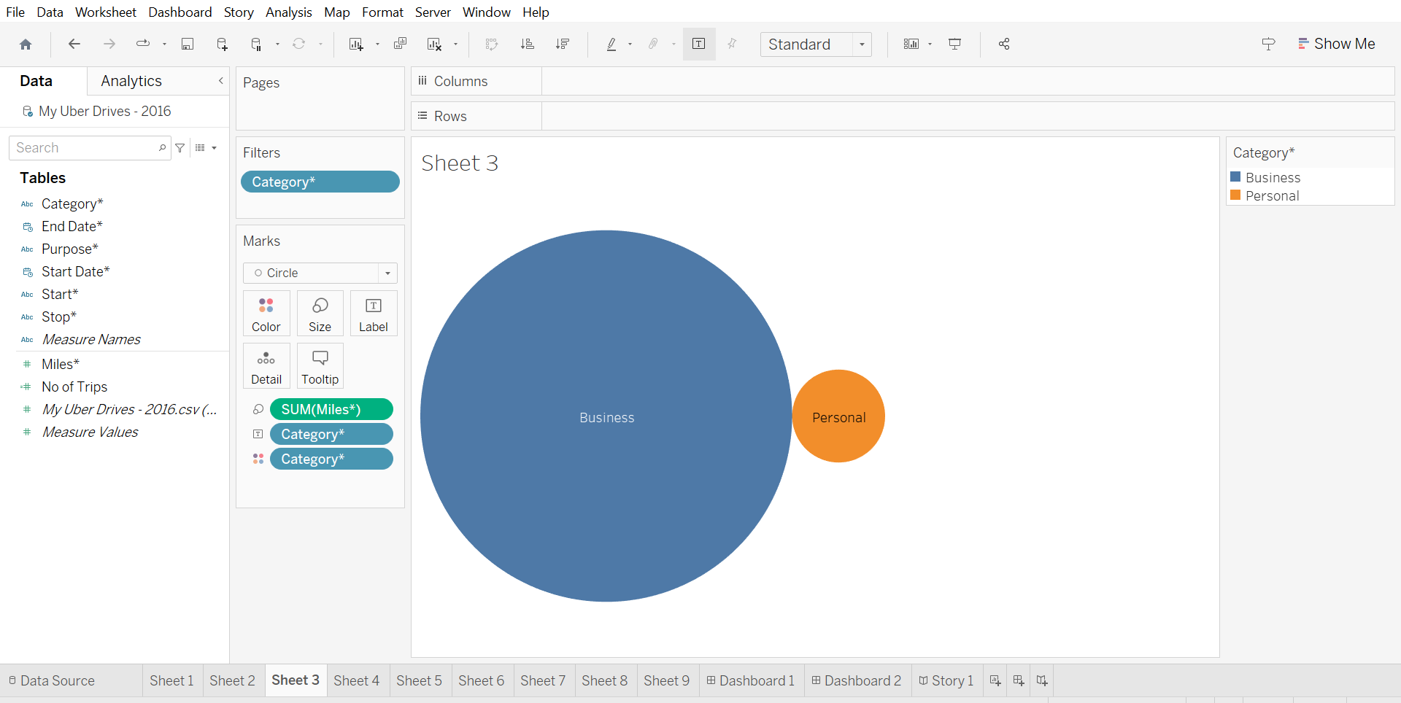

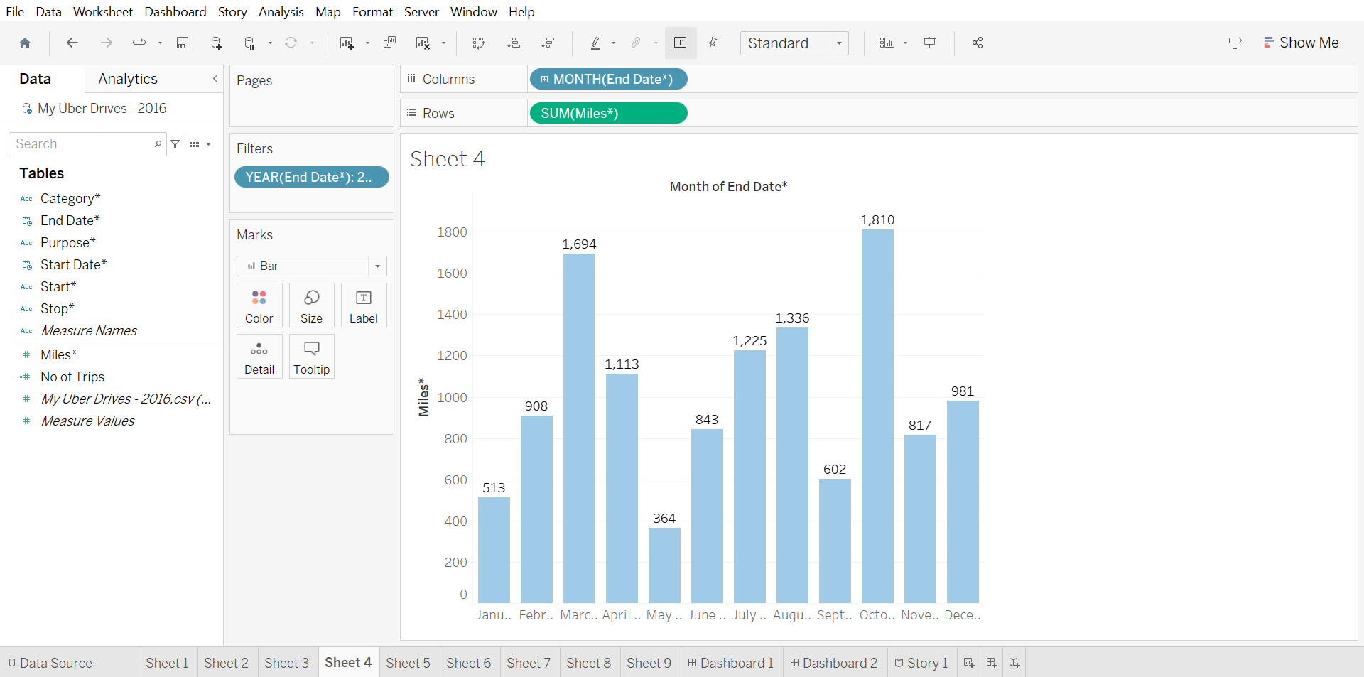

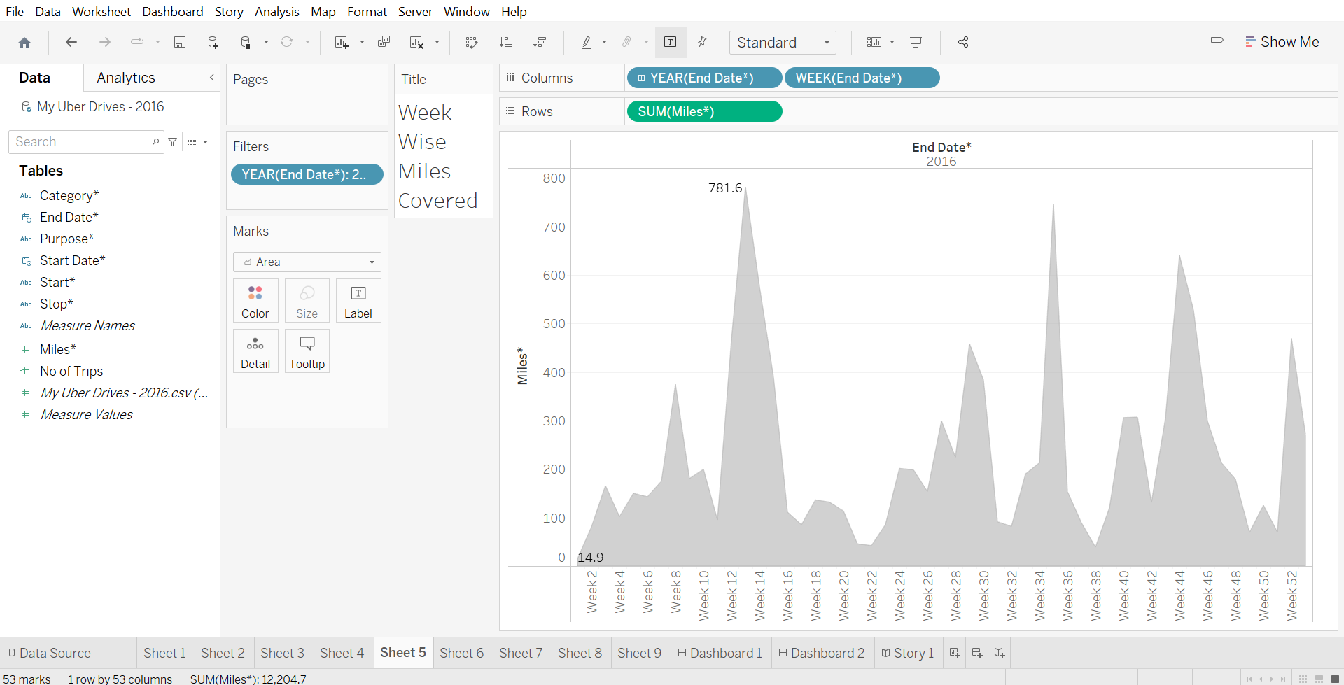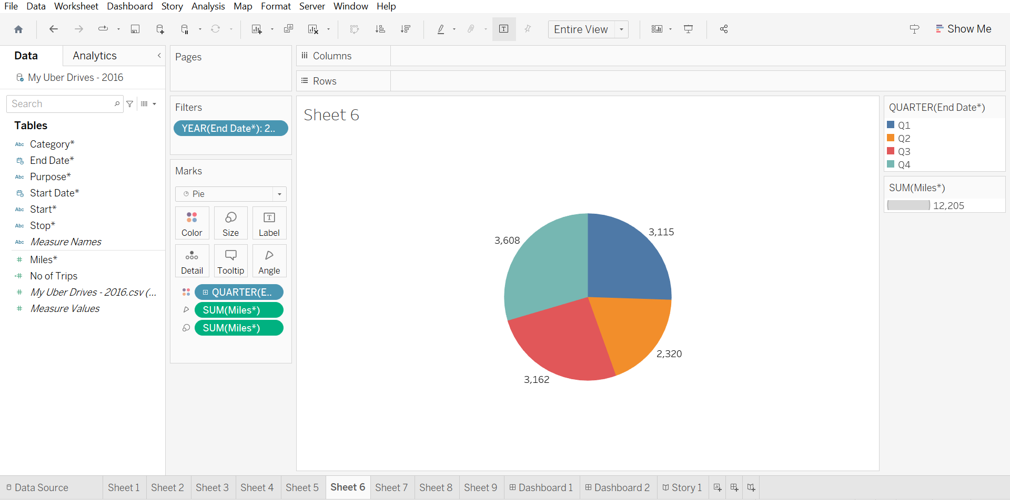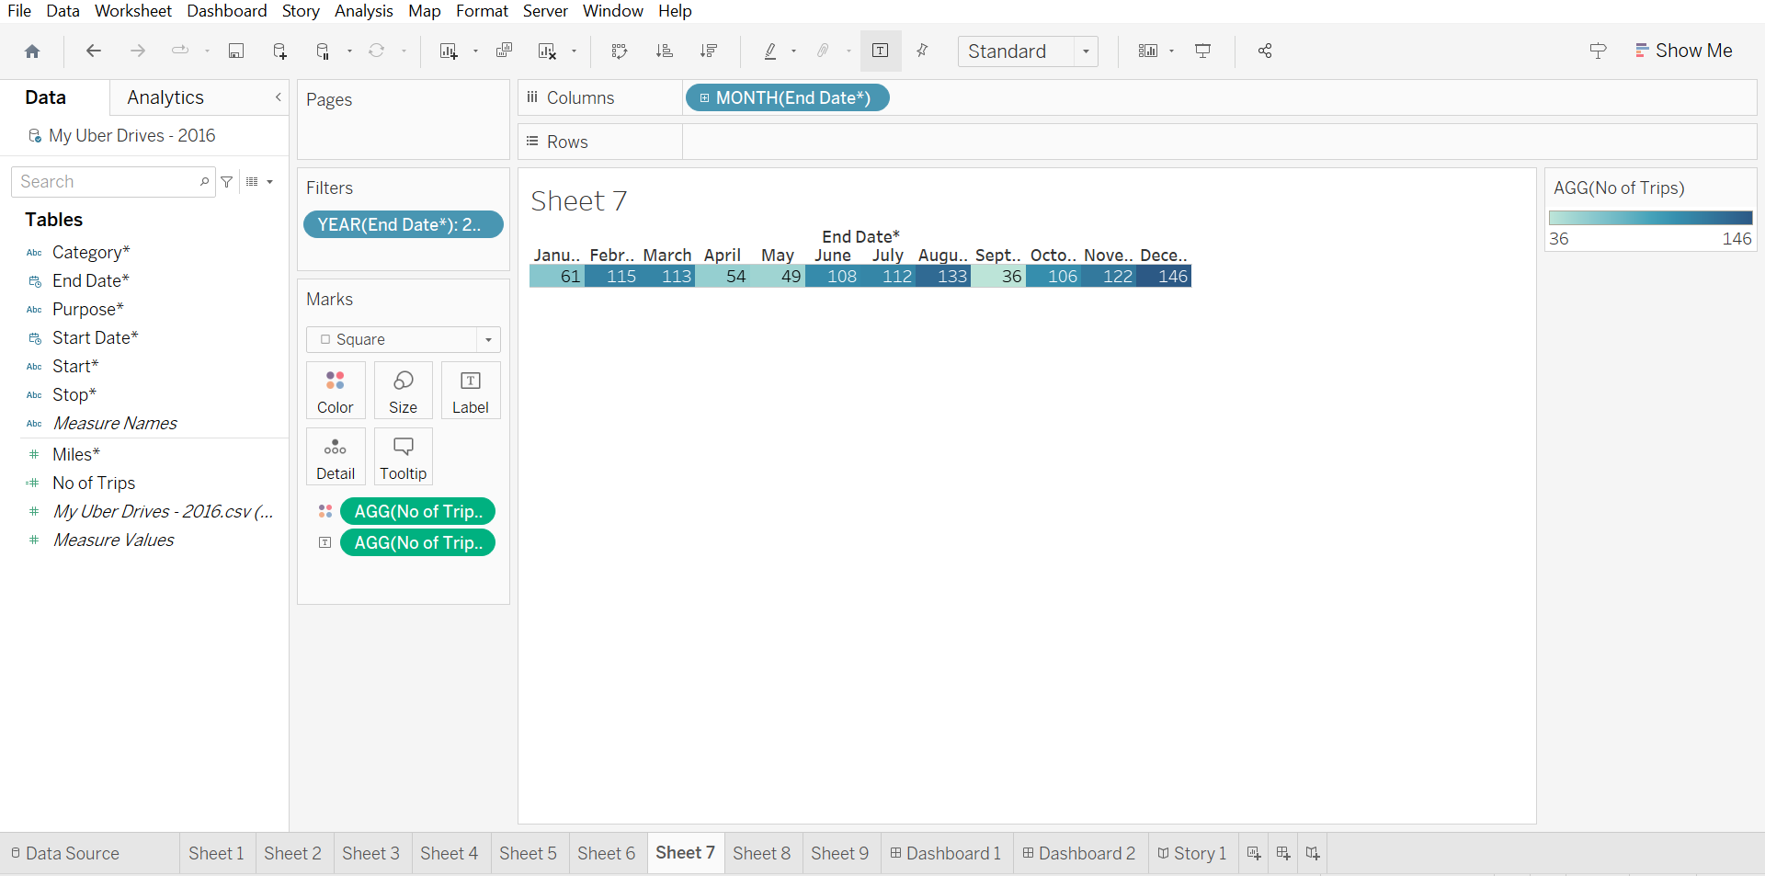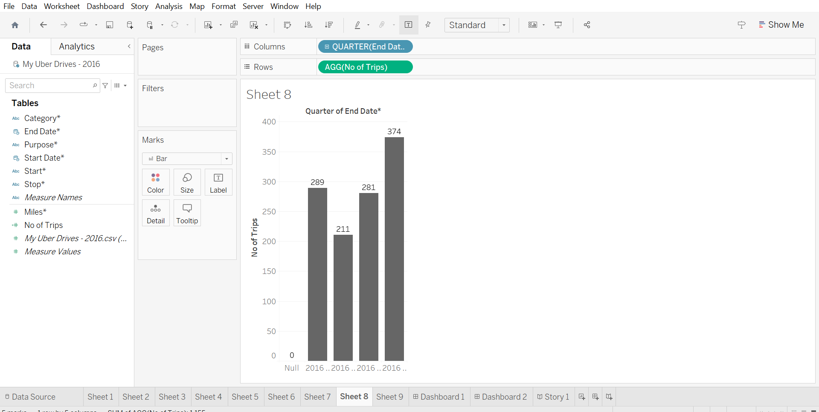

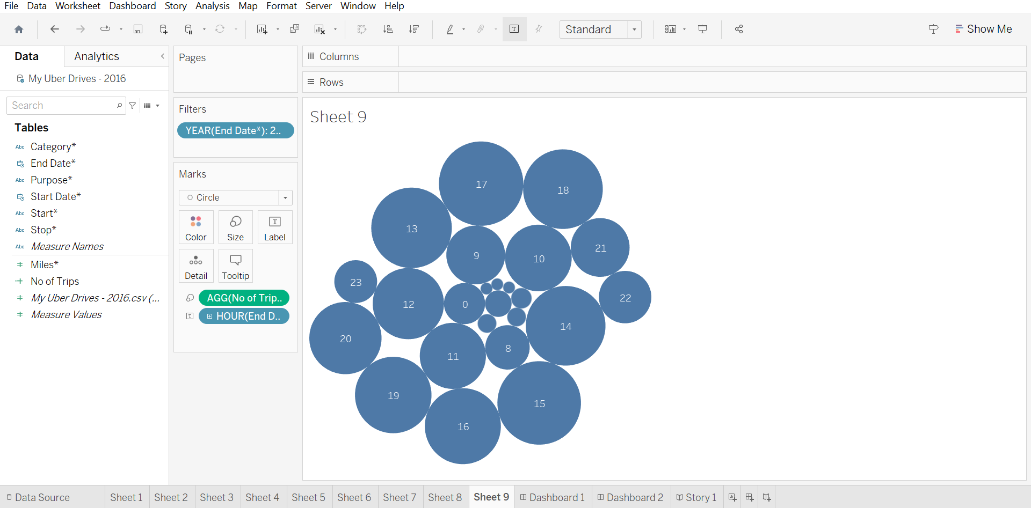

After finishing the analysis data, add a dashboard.

In the dashboard we can combine more sheets in single dashboard. The dashboard contains the combine of sheet that we created.

|  |
| --- |
| **RESULTS.** |

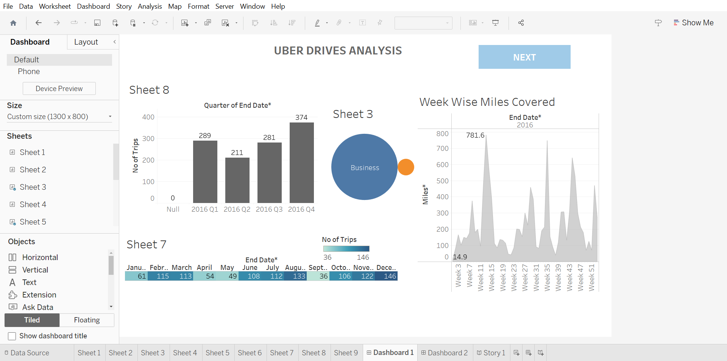

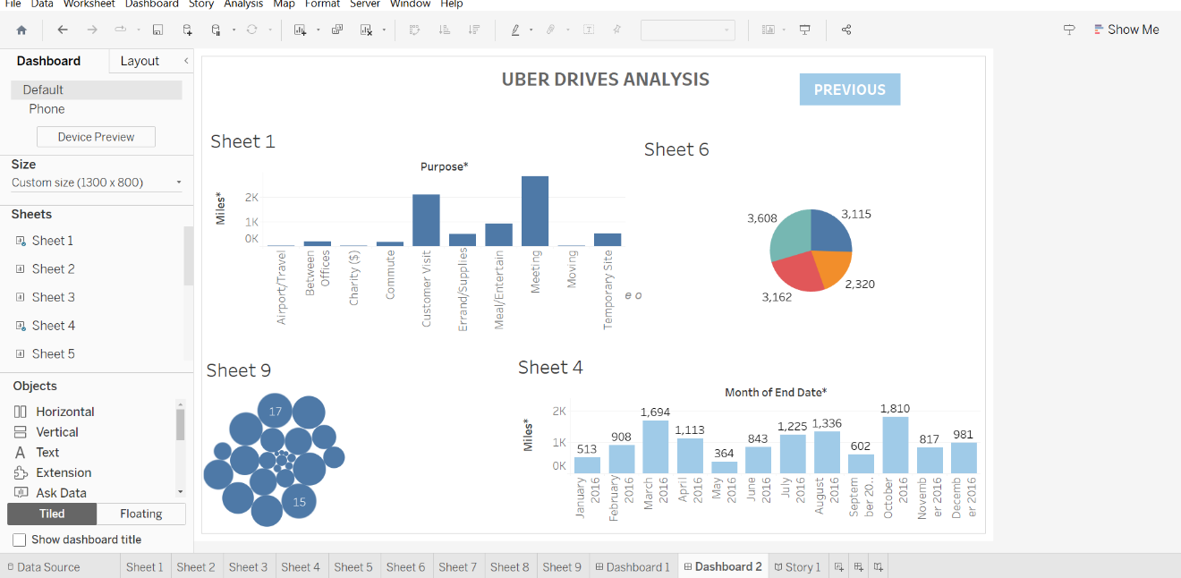

We created a story in the tableau desktop.

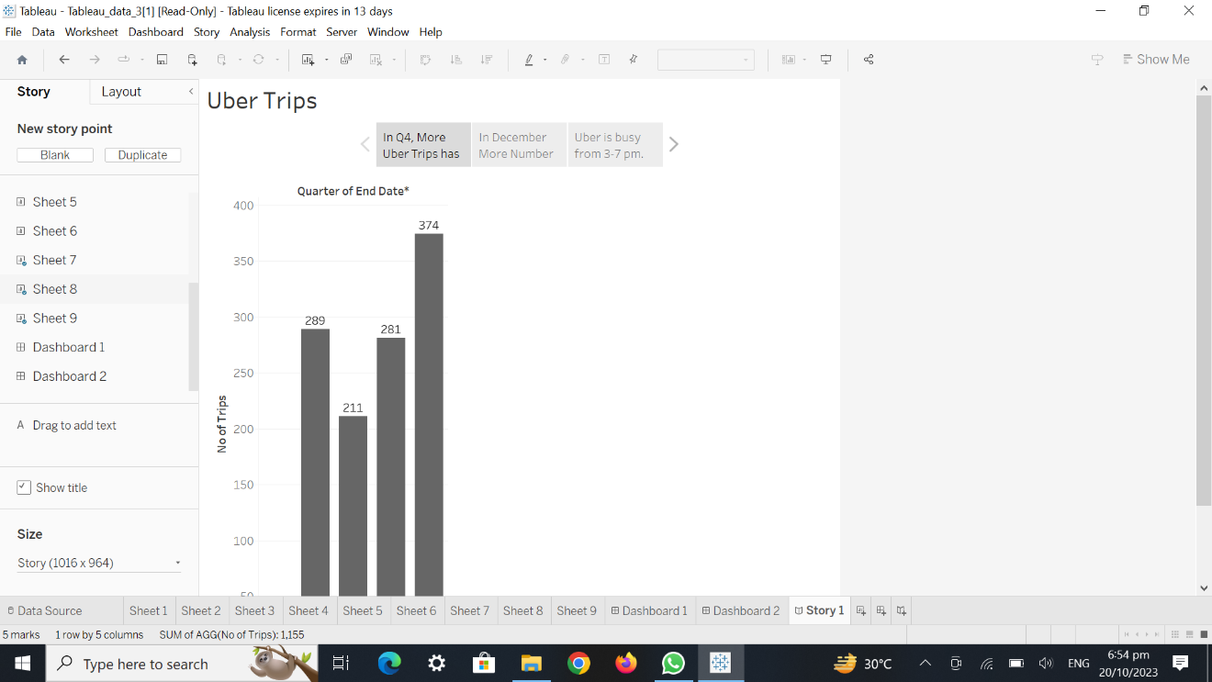

Sign into the tableau account.

Public the workbook in the tableau cloud.

Upload the project in the gitub.

|  |
| --- |
| **ADVANTAGES:** |

It used to user to get a holistic view of the entire data one screen about the transportation network.

It used to saves times and resources.

This visualizing and analyzing is very easier to analyses the data of the ubers and it helps in marking business decision.

|  |
| --- |
| **DISAVANTAGES.** |

It does not provide the feature of automatic refreshing of the reports with the help of uber expeditionary analysis.

|  |
| --- |
| **APPLICATION:** |

This visualizing and analyzing is very easier to analyses the data of the uber expeditionary and it helps in making business decision.

|  |
| --- |
| **CONCLUSION:** |

The tableau desktop is very useful to analyses the large number of data in one screen. We have learn how to analyses the data, how visualizing the data and how to create a dashboard and story.

Our project is unlocking insight into the uber expeditionary and has more 10 sheets , 2 dashboard and 1 story.

|  |
| --- |
| **FUTURE SCOPE:** |

Easy to analyses the data of uber expeditionary for the business and other purpose.